Trey Causey
DS&A w/ C++
7/4/08

Seminar Three Discussion Question

How many distinct binary trees can you find s.t. their preorder traversal is H-A-R-D? How many distinct binary trees can you find s.t. their inorder traversal is H-A-R-D? Are both answers equal? If not, why?

In answering this question, I had to consider two possibilities. One being that node labeling can only be done in alphabetical order and the other where labels can be assigned in a convenient way. The alphabetical way being where the root node is labeled A, the L_{A} being B and the R_{A} being C and so on (as in Fig. 1). The convenient way being how the root node could be of any label and its children nodes of any label. For the first way the answers are both 0 because each instance would not allow the H to be outputted before running into either an empty node or another node before reaching the H.

Fig. 1
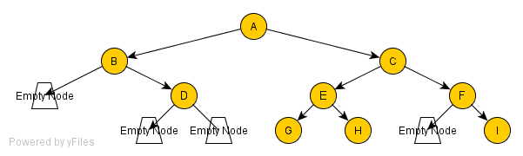

For the second way, the number of preorder traversals is twelve. The first starts with H, where L_{H} is A and R_{H} is and empty node. L_{A} is R and L_{A} is empty. L_{R} is D and R_{R} is empty. Both L_{R} and L_{R} are empty (as in Fig. 2). And some of the rest are shown in fig. 3 - 9
Fig. 2
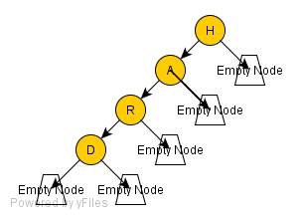
Fig. 3
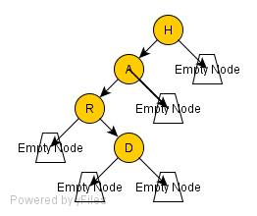

Fig. 4
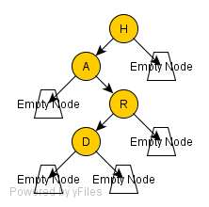
Fig. 5
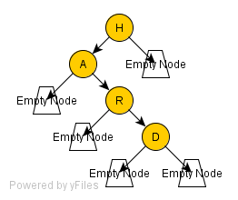
There are four other ways that are the opposite of these.
In addition, there is:
Fig. 6
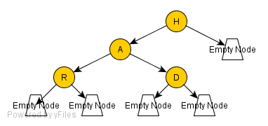
Fig. 7
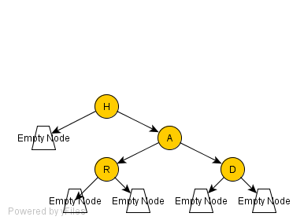
Fig. 8
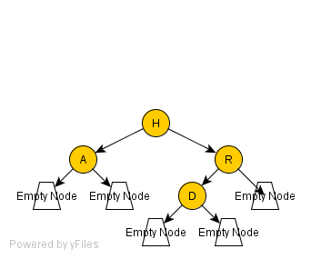
Fig. 9
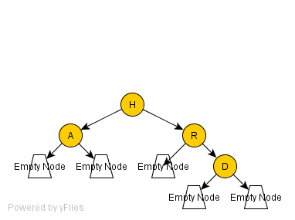

The amount of inorder ways seems to be five. The five are graphed below in figures 6 – 11. Fig. 11 is the only one that is shared with preorder, so if we are saying distinct as in the number of unique not shared by another method then it would only be four.
Fig. 10
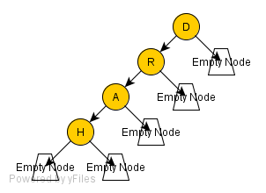
Fig. 11
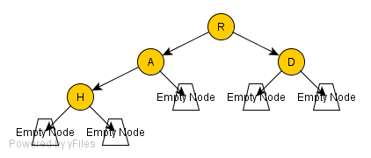
Fig. 12
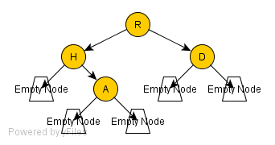
Fig. 13
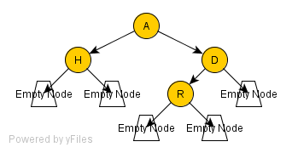
Fig. 14
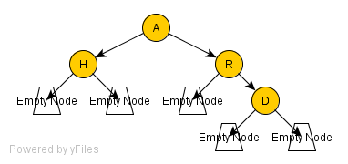
Fig. 15
